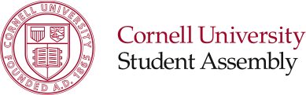

|  |  |
| --- | --- |
| Originally Presented On |  |
| Type of Action | Internal Policy |
| Status/Result | New Business |

**S.A. Resolution # X**

**Approval of Student Assembly Judicial Commission Charter & Bylaws**

**Sponsored by: Ulysses Smith ’13, Jordan Berger ’17, Scott Seidenberger ‘16**

**Whereas**, the Student Assembly Judicial Commission is charged with safeguarding the integrity of the internal policies and procedures of the SA and providing a peer review method of dispute resolution;

**Whereas,** all governing documents of the SAJC and new commissioners must be approved by a majority vote of the SA;

**Be it therefore resolved,** that the SA accept the attached Charter and Bylaws of the Student Assembly Judicial Commission.

**Be it finally resolved,** that in the founding year two (2) of the commissioners will serve terms ending at the conclusion of the 2014-2015 academic year, and two (2) of the commissioners will serve terms ending at the conclusion of the 2015-2016 academic year.

**Respectfully Submitted,**

Ulysses Smith ‘13

*President, Student Assembly*

Jordan Berger ‘17

*Parliamentarian, Student Assembly*

Scott Seidenberger ‘16

*Judicial Affairs Task Force, SA Community Life Committee*

*Reviewed by:*