Initial Report
Last Modified: 11/01/2012
EDP survey results
Education Committee
March 2012

The goals of this survey include:
- To gather preliminary information on the successful experience of employees who have graduated from the EDP program.
- To be able to create motivation among employees interested in furthering their education by creating an information source through this survey.
- To be able to provide anonymous survey results for the benefit of future EDP aspirants in particular and all employees in general.
- To create awareness among employees at Cornell regarding Educational assistance offered to them.
Survey population: Employees who have graduated from the EDP program and whose names are enlisted on the Cornell Benefits Website.
Key Statistics: 71 % response rate, 97 % completion rate.
Focus areas of feedback received:
- Flexibility
- Supervisory Support
- Tax implications

For more information on the survey or questions about the Education Committee e-mail lgs56@cornell.edu.
1. How did you know about the educational benefits offered by Cornell?
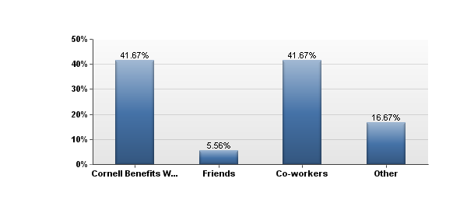

2. My supervisor was supportive of my participation in the Employee Degree program.
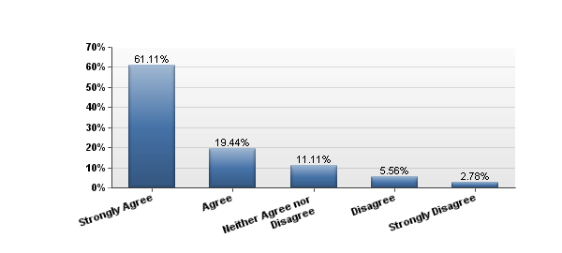

3. My colleagues/co-workers were fully supportive of my efforts towards furthering my education
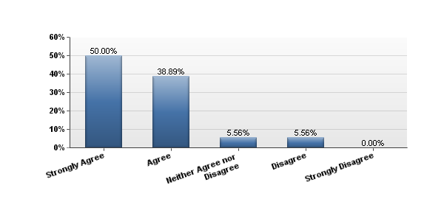

4. What was the biggest motivating factor to pursue further studies?
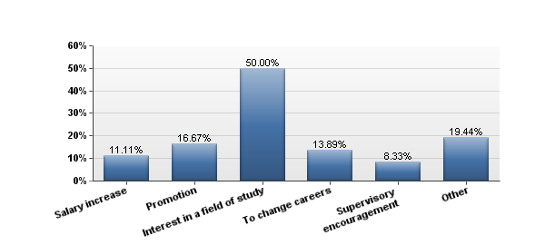

5. What was the biggest determinant in choosing college/university?
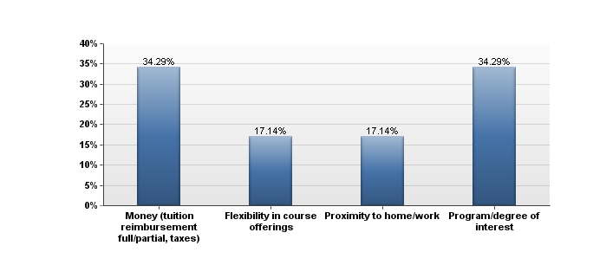

6. What were the factors that helped you FINISH your studies/degree?
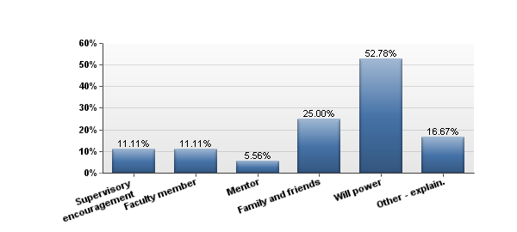

7. What were the biggest challenges in pursuing a degree while working full time?
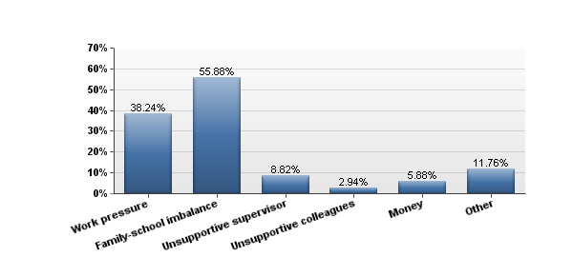

8. Do you think there is a need for more information/visibility regarding educational benefits offered by Cornell to its employees?
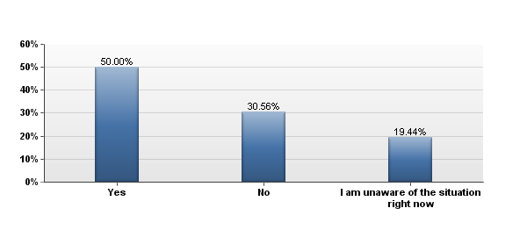

Other questions asked included:
How many years did it take you to graduate from the EDP?
How can supervisors show their support for employees taking classes? Suggestions for future aspirants.

