Report on Sexual Assault Response Initiatives

INITIATIVES
- Mandatory Orientation Information Session Initiative
  - We want to create an orientation session to educate freshmen/transfer students
  - Focused on the importance of ongoing, verbal consent and ways individuals can try and reduce the likelihood of becoming a victim
- Wingman Resolution follow up from last year
  - Resolution 41, passed in April 2012, endorsed the sending of an email to all fraternity presidents regarding Wingman101, a peer to peer program designed to reduce sexual assault
  - Since then, the initiative has stagnated
  - We plan to work with the IFC to bring back the discussion regarding Wingman101 and find ways to both strengthen and promote the program
- Expansion of BLUE
  - Starting this year, the SA has funded BLUE, a late night shuttle service for students during specific times of the year, usually centered around prelim/exam times
  - Many campuses have late night shuttles that run at more regular intervals
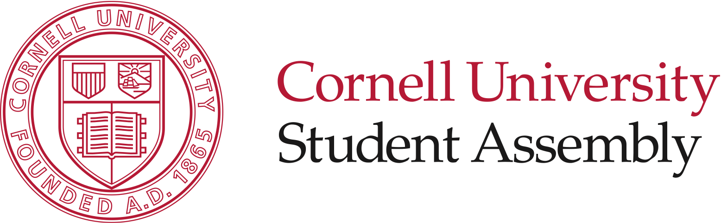
  - We want to explore the costs associated with an expansion of BLUE and investigate the feasibility of an expansion
- Buddy System PR Campaign
  - This would be a PR campaign similar to medical amnesty
  - Chief Zoner spoke frequently on the effectiveness of groups of students in preventing violent crimes such as rape and theft
  - While not a formal buddy system, the program would be designed to encourage people to go out together and to return home together.
- Increased Camera Surveilance
  - CUPD is interested in installing event-driven cameras in certain areas on campus
  - Administration believes students to be opposed to cameras
  - We will gauge student opinion and move from there
- Increasing Police visibility on campus
  - CUPD has found it hard to create relationships with students
  - They want our help in bringing them to events where they can reach students
  - The goal of such outreach is to make students more knowledgeable about the services CUPD provides and make them more comfortable with calling CUPD for help
- PR for Counseling/Self-Defense
  - Promote events through FB/Twitter/our website regarding classes/events on campus related to sexual assault prevention

